**Qualis LIMS (ReactJS) 1.0**

**Installation Qualification**

This information is believed to be complete and accurate as of publication, and is subject to change without notice.

Copyright © 2000—2010 Agaram Technologies. All rights reserved.

**Contents**

1. Purpose
2. Purpose
3. Scope
4. Validation Methodology
5. Acronyms
6. System Description
7. Introduction
8. Work Flow
9. Responsibilities
10. Test Plan
11. Prerequisites Review
12. Computer System Specification and Power Supply
13. Software Review
14. Qualis Installation Verification
15. Verifying components of the Qualis
16. Qualification Support Environment screen shots
17. Deficiency and Change Request Log
18. Document Approval

**1. Purpose**

The objective of this protocol is to verify the installation of the Qualis LIMS program and to   
 verify that it performs its intended function in a consistent and reproducible manner. Specific   
 test objectives and acceptance criteria are defined.

**1.1. Installation Qualification**

The Installation Qualification consists of tests to ensure that the components of the Qualis   
 LIMS program have been properly installed. Specific test objectives and acceptance criteria   
 are defined..

**2. Scope**

This protocol specifies the Installation Qualification tests that are to be applied to the Qualis   
 LIMS program, which will be used in a cGMP/cGLP environment, for the purpose of verifying   
 proper installation. The Qualis LIMS is installed to manage Laboratory workflows and data   
 proper installation. The Qualis LIMS is installed to manage Laboratory workflows and data   
 proper installation. The Qualis LIMS is installed to manage Laboratory workflows and data   
 Changes made to the software and/or computer systems after validation is completed must   
 be conducted under the appropriate system change control procedure. Parts of the protocol   
 may be used for reconfirmation or revalidation, if necessary.

**8. Qualification Support Environment screen shots**

**Tomcat**

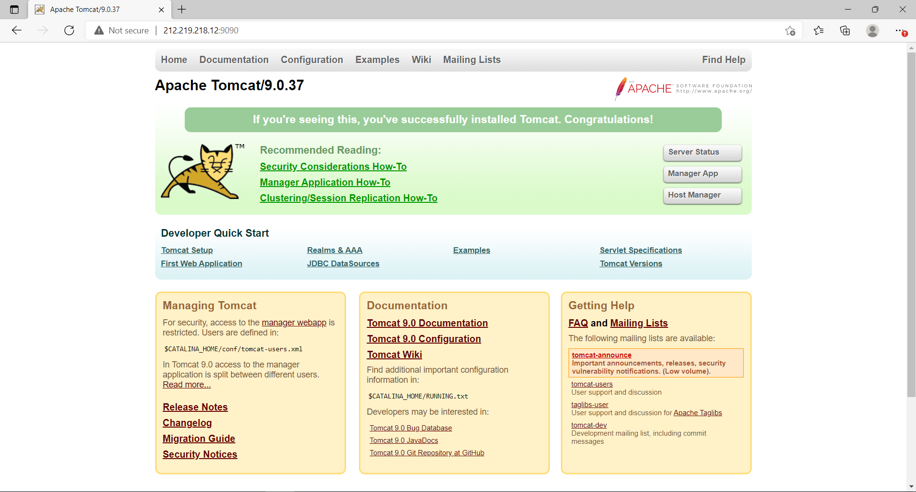

**ADS Services**

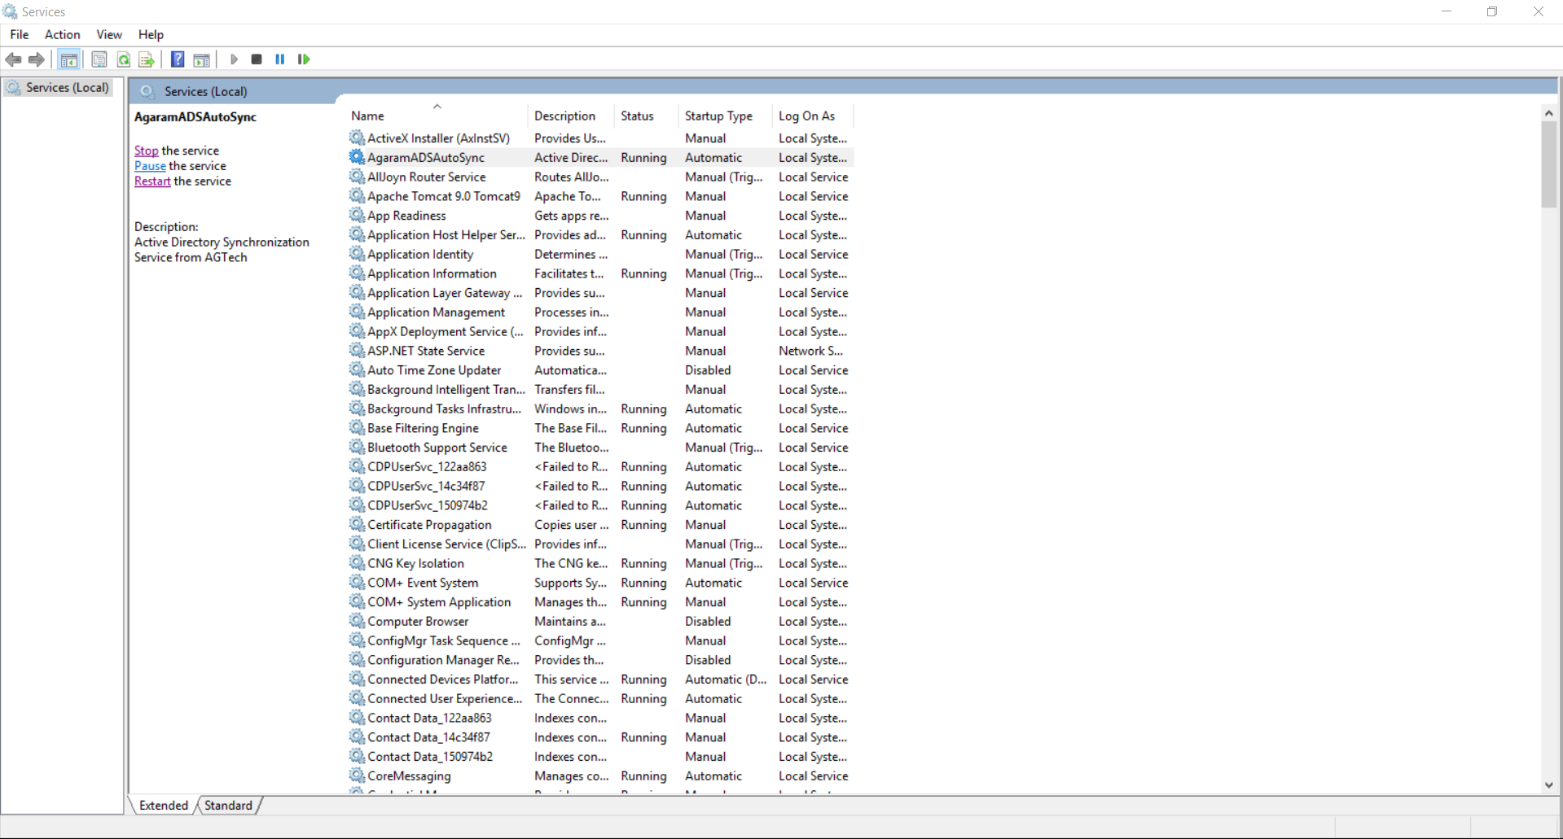

**IIS**

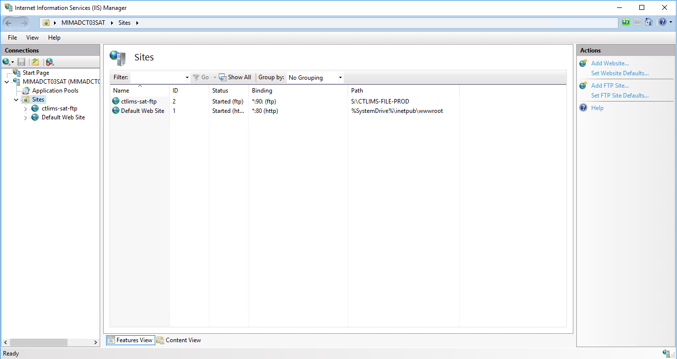

**Email**

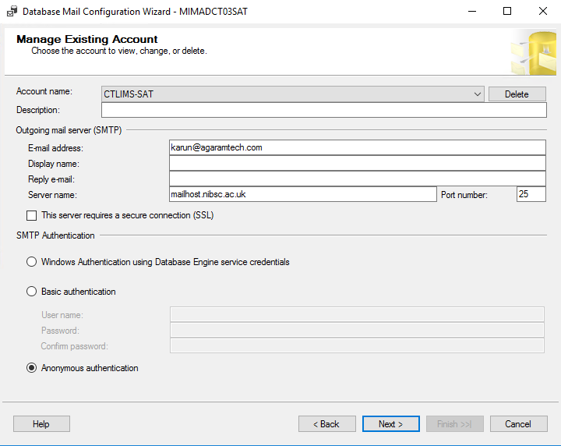

**Application**

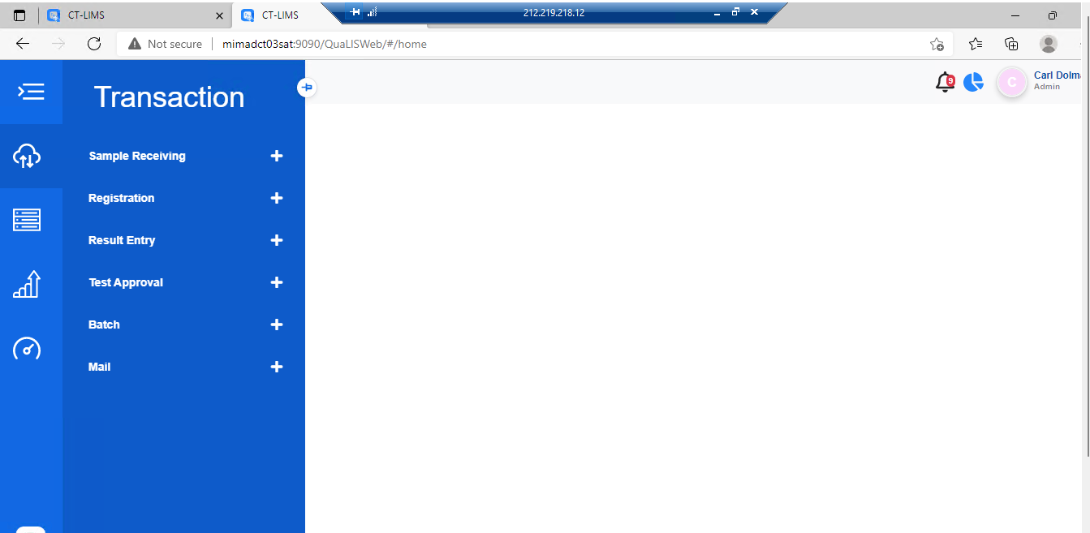

**9. Deficiency and Change Request Log**

In the following Deficiency Log, record the deviation numbers for any created deviation reports. Include a brief description of the issue. When the deviation is resolved and approved, write the date resolved.

|  |  |  |
| --- | --- | --- |
| **Deficiency number** | **Brief description** | **Date resolved** |
|  |  |  |
|  |  |  |
|  |  |  |
|  |  |  |
|  |  |  |
|  |  |  |

**10. Document Approval**

The Operational Qualification document has been reviewed and approved.

|  |  |
| --- | --- |
|  |  |
|  |  |
|  |  |
|  |  |
|  |  |
|  |  |